Preparation of the initial wave packet for the quantum interferometer-gravimeter
Adamov Kirill Nikolaevich^{1, 2}, Kapusta Dmitriy Nikolaevich^{1, 2}, Bonert Anatoly Ernstovich¹, Goncharov Andrey Nikolaevich^{1, 2, 3}

¹Institute of Laser Physics SB RAS, Novosibirsk, Russia
²Novosibirsk State University, Novosibirsk, Russia
³Novosibirsk State Technical University, Novosibirsk, Russia
e-mail: ofadamovkirill@gmail.com

The precise measurement of gravitational acceleration represents a significant challenge in modern science and technology. High-sensitivity and high-precision gravimeters, as instruments for detecting gravitational acceleration, play a crucial role both in fundamental research and in addressing a wide range of applied tasks. Of particular importance are absolute quantum gravimeters, which offer several key advantages: absence of drift, lack of moving mechanical parts, high measurement speed, and the potential for integrating gravimeter, gyroscope, and accelerometer functionalities within a single device.
The accuracy of a quantum gravimeter depends on the characteristics of the ultracold ⁸⁷Rb atom source, including the atom number in the cloud, their temperature, the efficiency of preparing the initial atomic wave packet, and other related factors. A significant influence on sensitivity and stability is exerted by various sources of noise, with vibrational noise contributing the most. To suppress vibrational noise, a vibration-isolation platform is employed in conjunction with a signal post-correction system [2], or alternatively, an active compensation system for vibrational disturbances is used.
In this work, we investigate the preparation of ultracold ⁸⁷R atoms in a magnetically insensitive quantum state for application in an atomic interferometer-based gravimeter. Numerical modeling of the optical pumping of rubidium atoms to the ∣F=1,m​=0⟩ state was performed using the ∣F=1⟩↔∣F′=0⟩ transition by numerically solving rate equations that describe the population distribution among the magnetic sublevels of the ground state [1]. The simulation results demonstrated high efficiency of the selected pumping scheme (about ~100%) without significant heating of the atomic cloud. Implementation of this methodic enabled the preparation of ⁸⁷Rb atoms in the magnetically insensitive ∣F=1,mF​=0⟩ state with an efficiency exceeding 95% (see Fig. 1(a)) and a temperature increase of less than 1 μK. The use of optical pumping resulted in more than a fourfold improvement in gravimeter sensitivity, achieving a sensitivity of 5.2 mGal/√Hz (see Fig. 1(b)).
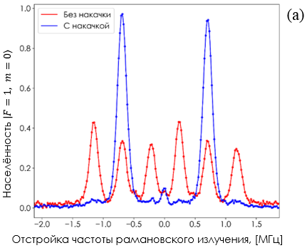 | 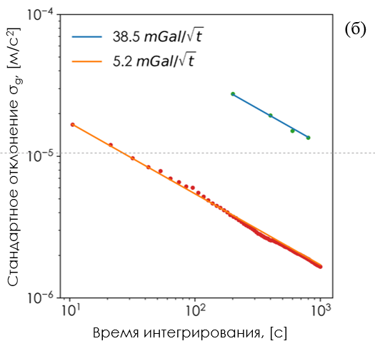
Fig. 1. The dependence of the atomic population before and after optical pumping on the detuning relative to the hourly transition (a) and the dependence of the standard deviation σ_{g} gravitational acceleration on the averaging time after optical pumping (b).
An investigation of vibration noise compensation using a post-correction signal method with an accelerometer was also conducted. The implementation of this technique led to improved output metrological characteristics of the gravimeter.

[1] F. Antoche, A. Kastberg Simplified approach for quantitative calculations of optical pumping // European Journal of Physics. - 2017. - №4. - С. 045703.
[2] J. Guo, S. Ma, C. Zhou, J. Liu, B. Wang, D. Pan, H. Mao Vibration compensation for a vehicle-mounted atom gravimeter // IEEE Sensors Journal. - 2022. - №13. - С. 12939-12946.

